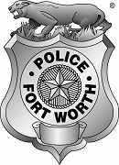 | Fort Worth Police  CODE BLUE  Charity  Golf Tournament | 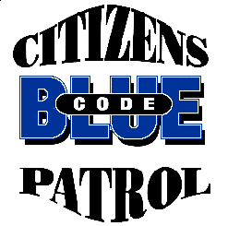

The Fort Worth Police Department is pleased to invite you to participate in the 31st Annual CODE BLUE Charity Golf Tournament on Monday May 5, 2025. Our partnership with the business community makes the City of Fort Worth a unique place to live, work and play. We are asking for your sponsorship to make this year’s tournament another success in supporting our Citizens On Patrol program. Listed below are ways to get involved:

Sponsors: On behalf of CODE BLUE, the Fort Worth Police Department and the Tournament Committee, we invite you to participate at one of the following sponsorship levels:
- $250 to $999: Course sign with company name, displayed the day of the tournament
- $1000 to $1999: Full team (4) registrations and a course sign with company name, displayed the day
of the tournament
All sponsors and contributors will be recognized for their contributions at the awards presentation following the tournament. Sponsors are also welcome to bring their own banners to display during the tournament.

Contributors: Contributions of drinks (water, sports drinks, etc.), breakfast, lunch and snack foods, raffle items, “swag bag” items are needed. Donations of gift certificates and merchandise are appreciated (monetary donations can also be made online at https://codebluegolf.org/donations).

Golfers: The tournament includes 18 holes of golf, special gifts, contests, raffle prizes, with free breakfast, lunch and snacks on the course, and an awards presentation. Tournament participants also receive a “swag bag” at check-in. Registration Fee: $150 per person / $600 per team (please visit https://codebluegolf.org for more info)

What is CODE BLUE? Since 1991, The Fort Worth CODE BLUE Citizens On Patrol volunteers have been patrolling neighborhoods and reporting suspicious activity, resulting in a 63% decrease in Part I Crimes since 1995! There are over 800 active registered volunteers patrolling more than 200 neighborhoods acting as our extra eyes and ears.


About Us: For the last three decades, Charity Golf Outings (a 501(c)(3) public charity) has supported Code Blue by organizing this charity golf tournament to raise money. Each year the proceeds from this tournament are used to show gratitude to our Code Blue – Citizens On Patrol volunteers by providing funds for training, equipment, and a year-end appreciation and recognition luncheon. Last year over $17,000 was donated to the Code Blue Program!

Please join us for another round of great golf for a good cause!

Captain Brent Halford

Fort Worth Police Department
Committee President
events@codebluegolf.org
P.O. Box 40012 • Fort Worth, Texas 76140

